Feedforward Control

Feedforward control is a basic starting point for spacecraft rotational maneuver control. Assuming a rigid body spacecraft model in the presence of no disturbances and known inertia [J], an open loop (essentially feedforward) command should exactly accomplish the commanded maneuver. When disturbances are present, feedback is typically utilized to insure command tracking. Additionally, if the spacecraft inertia [J] is unknown, the open command will not yield tracking. Consider a spacecraft that is actually much heavier about it’s yaw axis than anticipated in the assumed model. The same open loop command torque would yield less rotational motion for heavier spacecraft. Similarly, if the spacecraft were much lighter than modeled, the open loop command torque would result in excess rotation of the lighter spacecraft.
Observe in Figure 1, a rigid spacecraft simulator (TASS2) has been modeled in SIMULINK. An open loop feedforward command has been formulated to produce 10 seconds of regulation followed by a 30º yaw-only rotation in 10 seconds, followed by another 10 seconds of regulation at the new attitude. The assumed inertia matrix is not diagonal, so coupled dynamics are accounted for in the feedforward command.
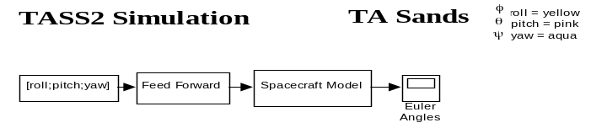
Figure 1 SIMULINK model of TASS2 Spacecraft Simulator

With no disturbances and a known, correct model, the open loop feedforward command can effectively perform the maneuver. The assumed, actual inertia used was experimentally determined for TASS2 spacecraft only (no optical payload).
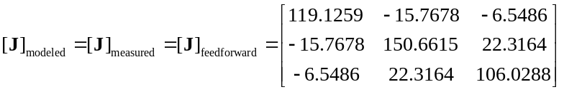
Recall in the real world systems are not always as we model them, disturbances are presence, and our sensor measurements of the maneuver will also be quite noisy (Figure 2). Nonetheless, the idealized case is a useful place to start, as it gives us confidence that our model has been correctly coded. Proof is easily provided by sending an acceleration command (scaled by the inertia) to the spacecraft model to verify the identical acceleration is produced (Figure 3). We have not yet added noise, disturbances, or modeling errors, so exact following should be anticipated. Next, we will alter the inertia [J] of TASS2. This is real-world, since the spacecraft has recently received its optical payload, so the yaw inertia components have increased significantly. Using the previous experimentally determined inertia [J] in the feedforward command should result in difficulties meeting the open loop pointing command.
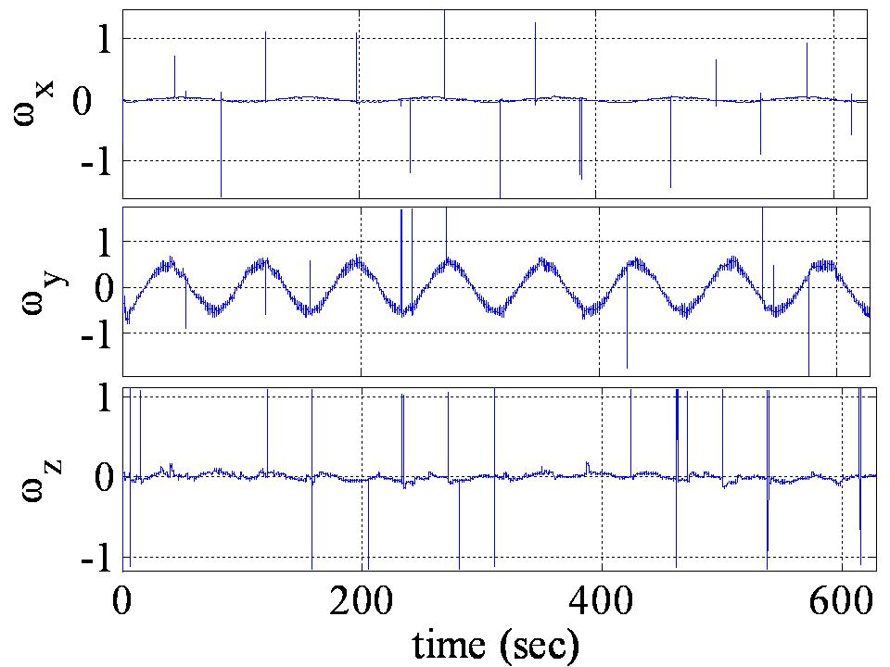
Figure 2 Sample angular rate measurement data from TASS2 experiments
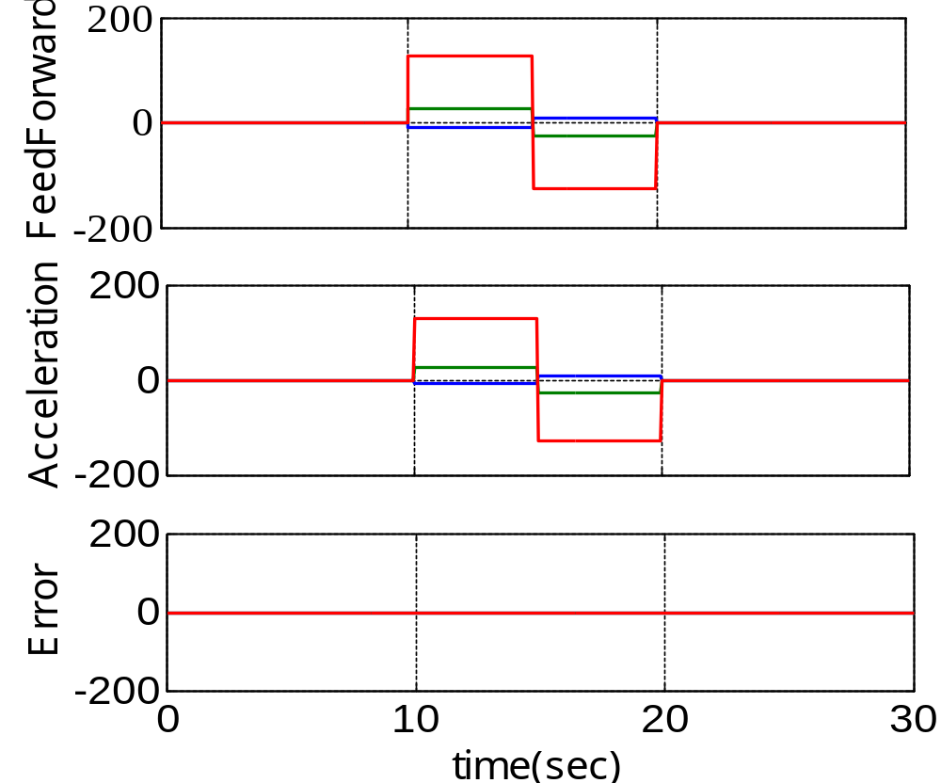
Figure 3 Feedforward input and resultant TASS2 acceleration (note zero error)
Notice in Figure 4 the maneuver is not correctly executed using the identical feedforward command for the assumed, modeled TASS2. The current inertia matrix has not been experimentally determined, so inertia components were varied arbitrarily (making sure to increase yaw inertia dramatically). This new inertia was used in the spacecraft model, but is presumed to be unknown. Thus, the previous modeled open loop feedforward command is used and proven to ineffective. Options to improve system performance include feedback, and adapting the feedforward command to eliminate the tracking error. Since adaptive control is more difficult, we will first examine feedback control with the identical models and maneuver.
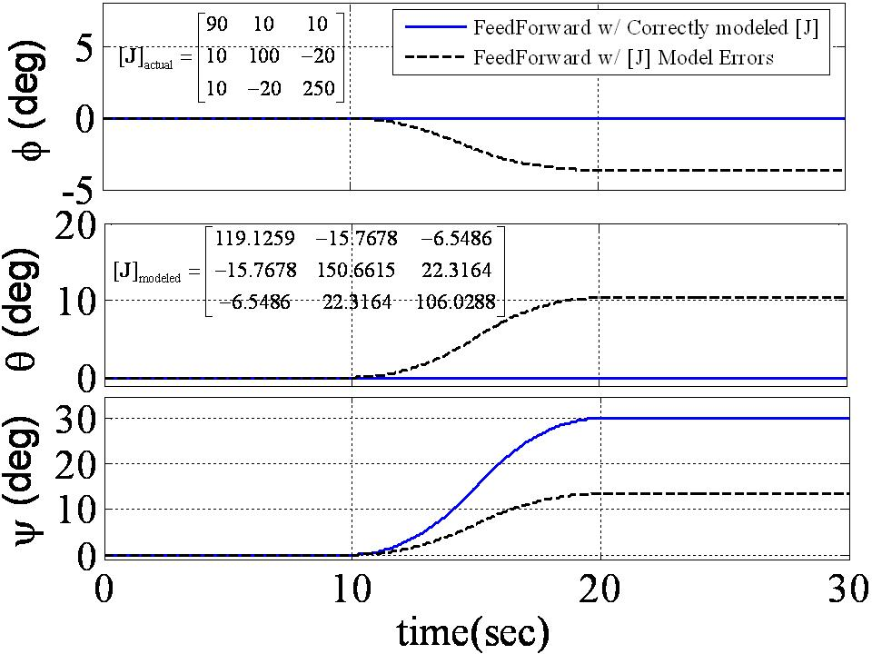
Figure 4 Open Loop Feedforward TASS2 Maneuver Simulation

Feedback Control

Feedback control components multiply a gain to the tracking error components in each of the 3-axes. When multiplying gains to the tracking error itself, the control is referred to as proportional control (or P-control). When multiplying gains to the tracking error integral, the control is referred to as integral control (or I-control). Finally, when multiplying gains to the tracking error rate (derivative), the control is referred to as derivative control (or D-control). Summing multiple gained control signals results in combinations such as: PI, PD, PID, etc. PD control is extremely common for Hamiltonian systems, as it is easily veritably a stable control. PD control was augmented to the previous case of feedforward control with inertia modeling errors (Figure 5) dramatically improving performance, while not restoring the ideal case.

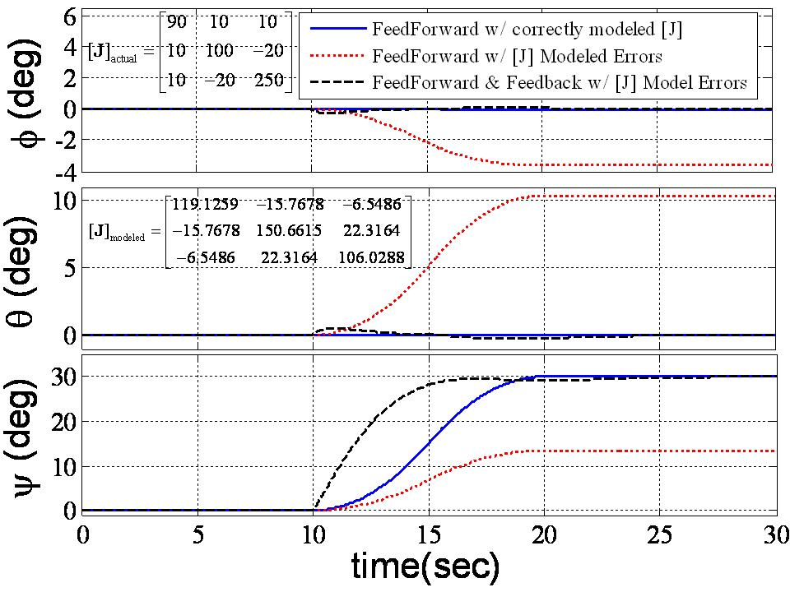
Figure 5 Demonstration of Feedback Control Effectiveness

It is clear that feedback control augmentation is a powerful tool to eliminate real world factors like modeling errors. An identical comparison was performed with gravity gradient disturbances associated with an unbalanced TASS2. The comparison is not presented here for brevity’s sake, but the results were qualitatively identical.
While feedback appears extremely effective to accomplish the overall tracking maneuver, some missions require faster, more accurate tracking with less error. Such missions often consider augmenting the feedforward-feedback control scheme by adding adaptive control to either signal.

Adaptive Control

Adaptive control techniques typically adapt control inputs based upon errors tracking commanded trajectories and/or estimation errors. Direct adaptive control techniques typically directly adapt the control signal to eliminate tracking errors without estimation of unknown system parameters. Indirect adaptive control techniques indirectly adapt the control signal by modifying estimates of unknown system parameters. The adaptation rule is derived using a proof that demonstrates the rapid elimination of tracking errors (the real objective). The proof must also demonstrate stability, since the closed loop system is highly nonlinear with the adaptive control included. Two fields of application of adaptive control is robotic manipulators and spacecraft maneuvers utilizing both approaches,,.
While some adaptive techniques concentrate on adaptation of the feedback control, others have been suggested to modify a feedforward control command retaining a typical feedback controller, such as Proportional-Derivative (PD). Adaptation of the feedforward signal has been suggested in the inertial reference frame,, but the resulting regression model requires several pages to express for 3-dimensional spacecraft rotational maneuvers. The regression matrix of “knowns” is required in the control calculation, so this approach is computationally inappropriate for spacecraft rotational maneuvers. Subsequently, the identical approach was suggested for implementation in the body reference frame. The method was demonstrated for slip translation of the space shuttle. This method appears promising for practical utilization in 3-dimensional spacecraft rotational maneuvers. A derivation of the Slotine-Fossen approach is derived for 3-dimensional spacecraft rotational maneuvers next, then implementation permits evaluation of the effectiveness of the approach in the context of the previous results for classical feedforward-feedback control of the TASS2 plant with modeling errors.

Indirect Adaptive Feedforward Command Derivation

The equation of motion may be written by various methods (Newton-Euler, Lagrange, Kane’s, momentum, etc.) as follows: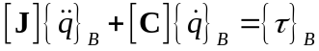where [J] is the inertia matrix, [C] is the matrix relating the motion rates to the Coriolis & centripetal forces, τ is the sum of external torques and q is the body coordinates (quaternion, Euler angles, etc.). The body coordinates may be transformed to inertial coordinates via the transformation matrix [S]: 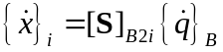. Similarly, we may define a reference trajectory in the body coordinates: 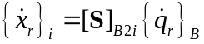. Rewriting the transformation and differentiating:
. This may be substitute into the equation of motion allowing us to express the equation of motion in terms of the reference trajectory.
Pre-multiplying by 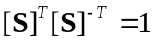 allows us to understand [Slotine]’s original approachError: Reference source not found:
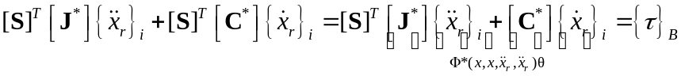
Slotine uses the linear regression model to define an equivalent system based on parameter estimates: 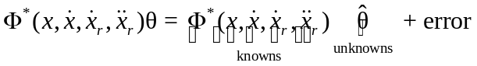. The estimatesare adapted using an adaption rule that makes the closed loop system stable. The regression model is then used in the control, which is where the complication arises. The 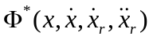 matrix of “knowns” occupies several pages and is used at each time step to formulate the adapted control signal making the method computationally impractical. [Fossen] on the other hand formulates the regression model in the body coordinates eliminated the complications seen above with the numerous multiplications with the coordinate transformation matrix [S]. Picking up from [Slotine]’s method above, we can simply express the regression model including the transformation matrix: 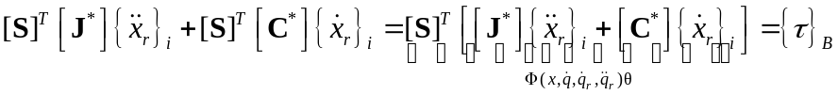 noting the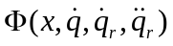matrix of “knowns” has no asterisk. Preface [Slotine]’s mathematical trick (pre-multiplication) above: . Continuing here yields [Fossen]’s substantial simplification through the following 3 steps:
- Solve the earlier defined transformation equations for 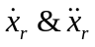:
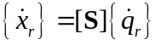
- Substitute into instead of pre-multiplying.
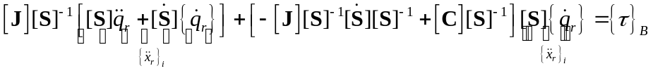
- Reduce this to linear regression form:
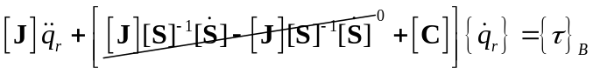
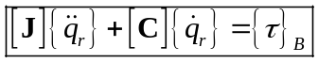
All that remains now is to multiply this out long-hand and regroup the terms into the linear regression model: 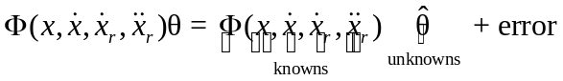. In order to do this, we must define the reference trajectory. The modifications to the overall feedforward control strategy may be embodied in these two venues: 1) estimate/adapt estimates of inertia in the regression model above, and 2) choose a reference trajectory that addresses system lead/lag when applying the assumed control to a spacecraft with modeling errors, disturbances and noise.

Reference Trajectory
Define the reference trajectory such that the control helps the spacecraft “catch up” to the commanded trajectory. If the spacecraft is actually heavier than modeled, it needs a little extra control to achieve tracking than will be provided by classical feedforward control. If the spacecraft is actually lighter than modeled, the control must be reduced so as not to overshoot the commanded trajectory. Consider defining the reference trajectory as follows: 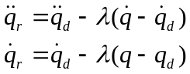.
Note we have scaled the reference acceleration and velocity to add/subtract the velocity and position error respectively scaled by a positive definite constant, λ. This should help the feedforward control component regardless of indirect adaption. Accordingly, subsequent sections will evaluate the effectiveness of the reference trajectory by itself and the also the indirect adaption/estimation by itself as well. First, let’s conclude the derivation by multiplying out the linear regression form so that the reader can have the simple equation for spacecraft rotational maneuvers.
Simplify 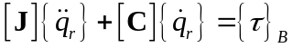 letting and use 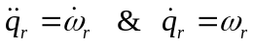:
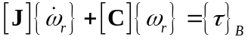
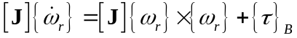
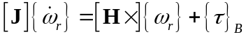 where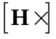is the skew symmetric matrix form of the momentum vector.
Expand 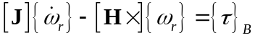
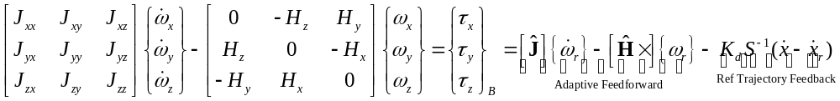
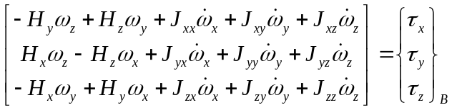
Letand assume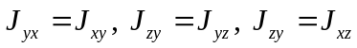 allowing us to express 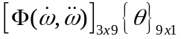:
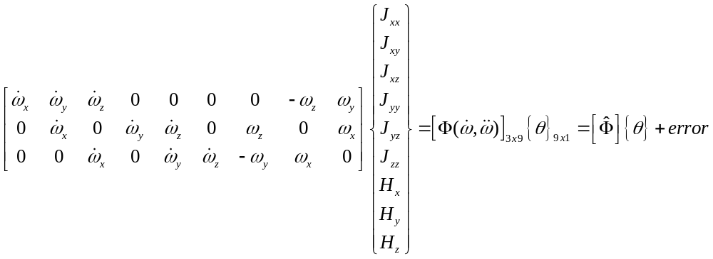
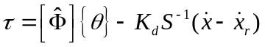 ← Use this control

Adaption Law Derivation

Where 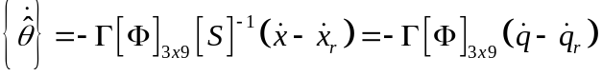 ← use this adaption rule

Indirect Adaptive Feedforward Effectiveness
Especially since typical feedback control deals with modeling errors effectively, we wish to evaluate the effectiveness of indirect adaptive feedforward control with a rigorously disciplined approach. Accordingly, the examination will evaluate the individual effectiveness of each control component in the following paragraphs:
- Reference trajectory without indirect adaption (feedforward, feedback, and both)
- Indirect adaption without a scaled reference trajectory (feedforward, feedback, and both)
- Indirect adaption with reference trajectory (previously derived application of [Fossen] suggested improvement to [Slotine]’s method)
The examination is performed by manually activating switches in the SIMULINK simulation model to insure all aspects of the maneuver are identical with exception of the aspect being switched for investigation. Note the feedback control is configured as a proportional-derivative-integral (PID) controller with the following gains: K_{p}=100, K_{d}=300, K_{I}=0, thus a PD controller.
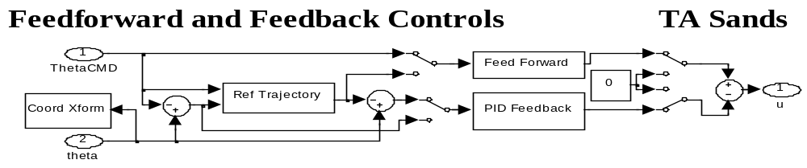

Reference Trajectory without Indirect Adaption

It seems likely that utilization of the reference trajectory alone should improve system performance without the computational complications of estimation/adaption. Consider the reference trajectory as derived previously: . This trajectory adds/subtracts a little extra amount (the previous integral scaled by a positive constant). If the system is lagging behind the desired angle for example, that lag is scaled and added to the reference velocity trajectory resulting in more control inputs. Since we use measurements to generate the reference command, it seems intuitively appropriate for feedback control. Nonetheless, it is implemented in feedforward, feedback, and both for completeness sake.
Referencing Figure 6, note that the reference trajectory with feedforward control only with a correctly modeled system is not effective. This makes sense, since the feedforward control on a correctly modeled plant with no disturbances was previously demonstrated to perform well (Figure 4) while unrealistic for real world systems.

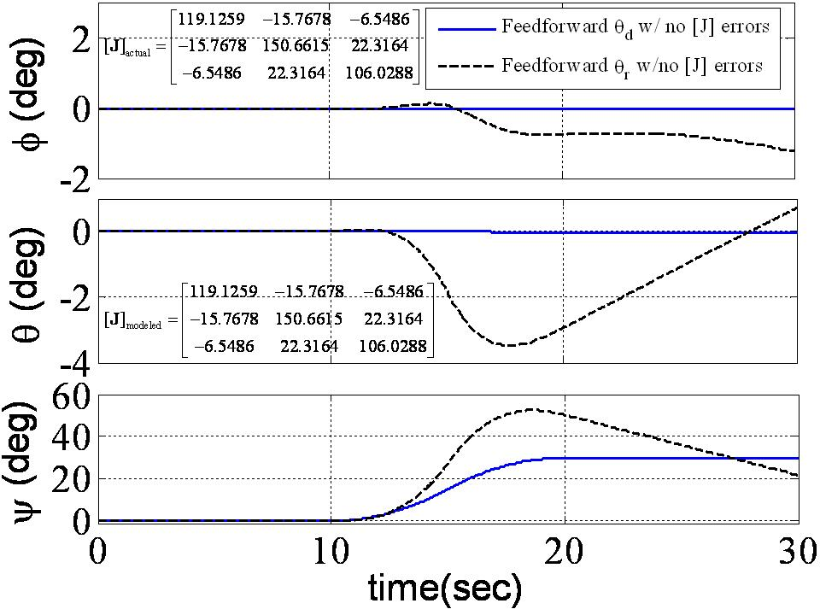
Figure 6 Feedforward (only) control with correctly modeled inertia

Next, consider the reference trajectory for a system that is not well modeled. As we saw previously (Figure 5), open loop control when the inertia is increased results in the system falling short of the desired maneuver. The control is designed for a lighter spacecraft. We see in Figure 7 that feedforward control alone with a reference trajectory fairs not better. As a matter of fact, the performance is worse. Addition of feedback control seems appropriate. Before examining feedback control added to feedforward control, first examine feedback control by itself so that we may see the effects of the reference trajectory. Notice in Figure 8 that when the model is well known (correct), feedback control works quite well, and system performance is dramatically improved using the reference trajectory. Again, this is intuitive since the control is given a little something extra to account for tracking errors. This is also important for us to remember when analyzing indirect adaptive control with a reference trajectory. Tracking performance can be improved considerably without the complications of inertia estimation/adaption if the system is the assumed model.
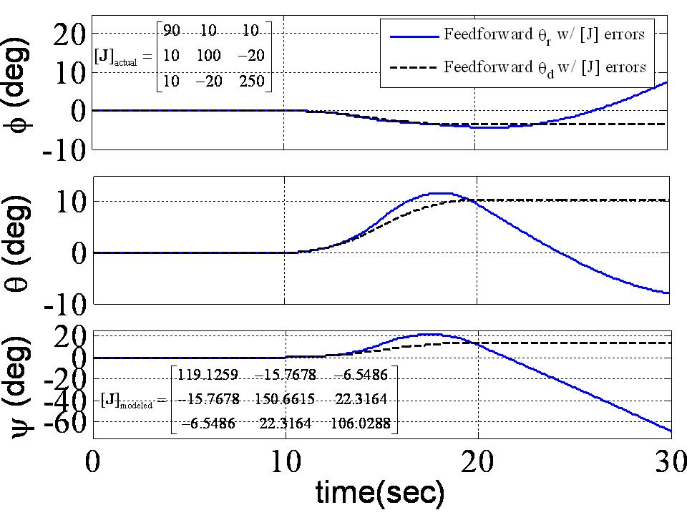
Figure 7 Feedforward (only) control with inertia errors

When the model is not known, or has changed considerably from its assumed form, the performance improvement using the reference trajectory is not as pronounced as just seen with a well known model. Figure 9 illustrates that system damping has been reduced by the addition of the reference trajectory. The initial response is much faster, but there is overshoot and oscillatory settling. Notice in this example the two plots settle in similar times, so use of the reference trajectory has not drastically improved or degraded system performance.
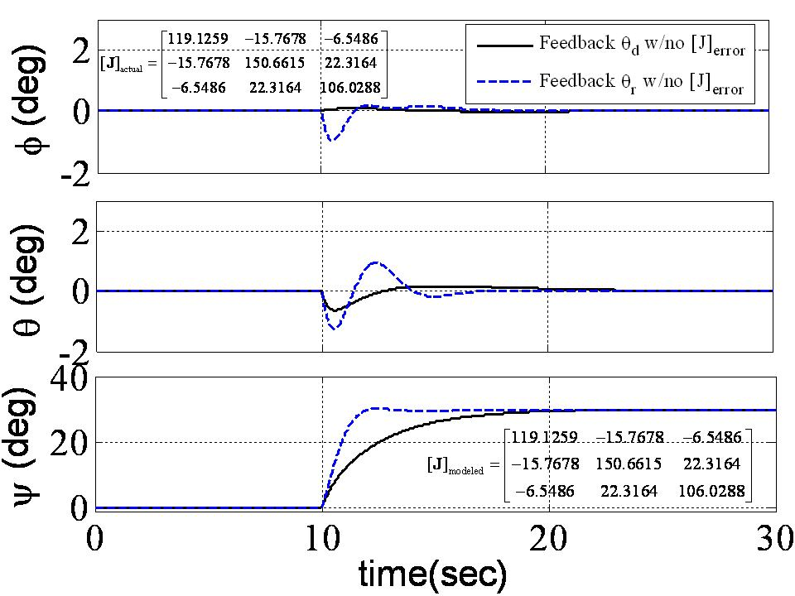
Figure 8 Feedback (only) control with correctly modeled inertia

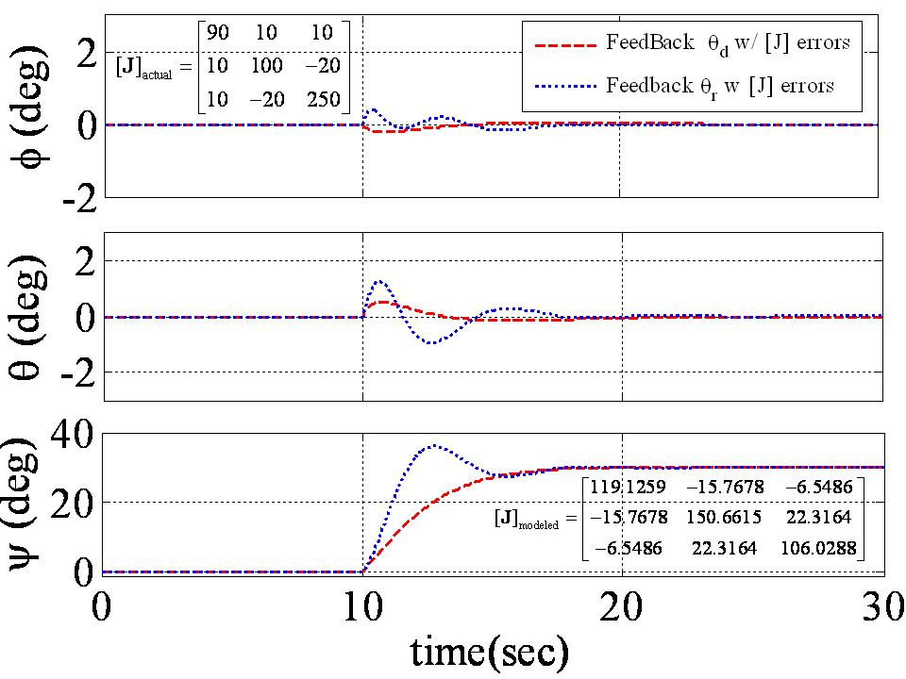
Figure 9 Feedback (only) control with inertia errors

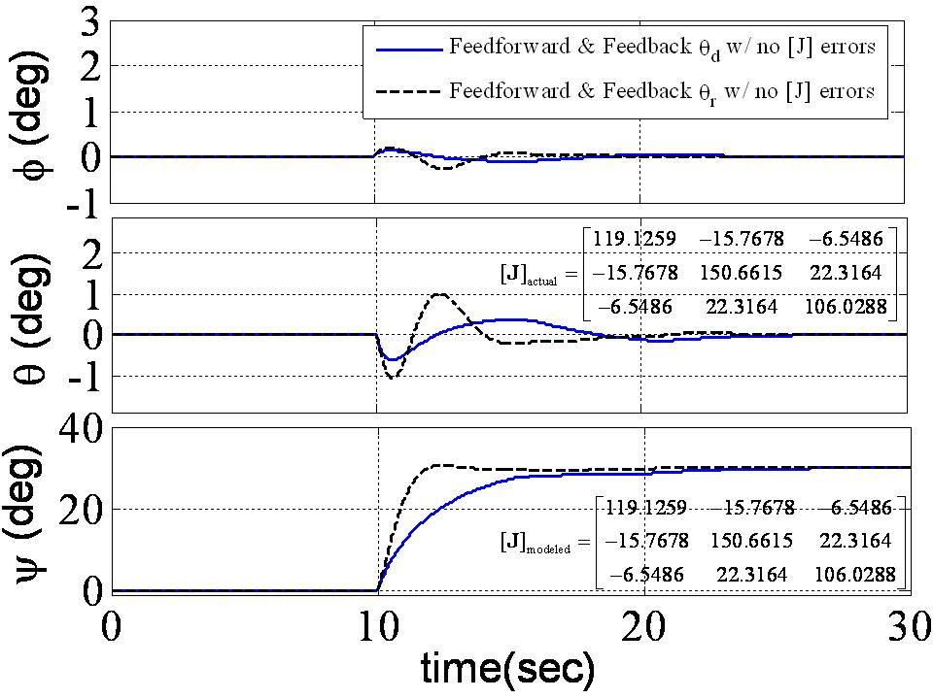
Figure 10 Feedforward & Feedback control with correctly modeled inertia

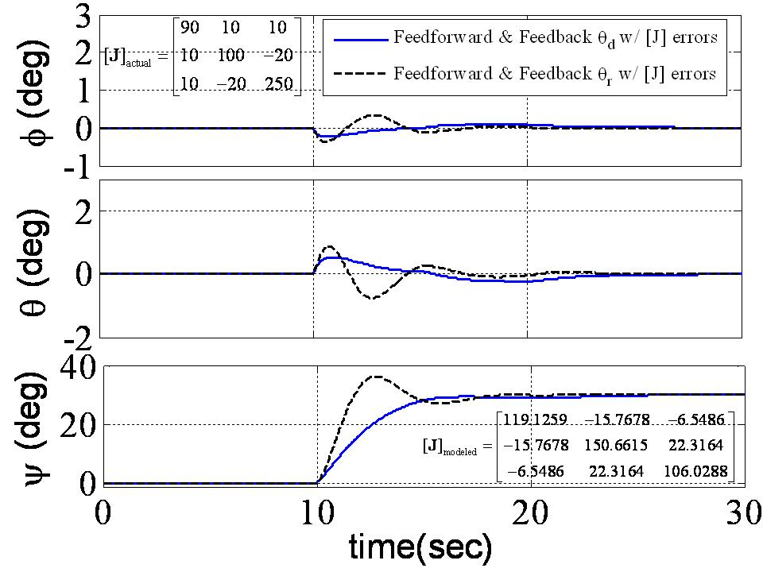
Figure 11 Feedforward & feedback control with inertia errors
Thus far, we see that the reference trajectory does not improve system performance when using feedforward control alone, but can improve performance with feedback control alone especially when the system inertia is known. Next, consider combined feedback & feedforward control. Figure 10 reveals expected results. Feedforward and feedback control with a reference trajectory is superior to using the desired trajectory when the plant model is known (no inertia errors). Similarly to the previous results, the reference trajectory with high inertia errors reduces system damping and exhibits faster response with overshoot and oscillatory settling. To conclude the evaluation of control with the reference trajectory without adaption/estimation, consider using the reference trajectory for feedback only and maintain the desired trajectory to formulate the feedforward control.
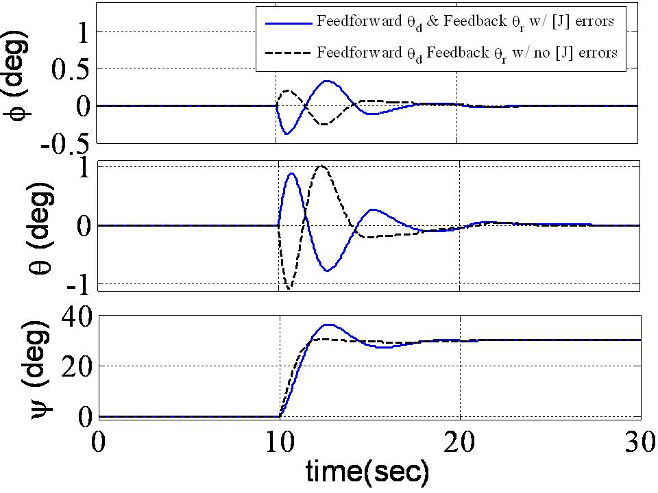
Figure 12 Feedforward θ_{d} & Feedback θ_{r} with and without inertia errors
Notice in Figure 12 the system performance is nearly identical to using the reference signal for both feedback and feedforward. This leaves us with a good understanding of how the reference trajectory affects the controlled system. To generalize:
- Feedback control may be improved by utilization of a reference trajectory that adds a component scaled on the previous integral tracking error. When the system model is known, performance is improved drastically. In the example, J_{zz} was altered >100% and the reference trajectory still effectively controlled the spacecraft yaw maneuver.
- Such reference trajectories are not advisable for feedforward control. Use of the reference trajectory in feedforward control does not improve system performance even in combination with feedback control.
Now that we have a good understanding that reference trajectories can improve system performance without estimation/adaption, let’s continue by examining indirect adaptive control without the reference trajectory.

Indirect Adaption without Reference Trajectory

Figure 13 displays a comparison of indirect adaptive control with and without a reference trajectory. In both cases, estimates are used to update a feedforward signal. The former case feeds the reference signal is generated by adding the scaled previous integral (scaled by a positive constant λ) as previously discussed. The later case sets λ=0 making the reference trajectory equal to the desired (commanded) trajectory. The figure reveals that adaption//estimation alone does not produce good control. The reference trajectory is a key piece of the control scheme’s effectiveness. This is intuitive having established the significance of the reference trajectory in previous sections of this study.
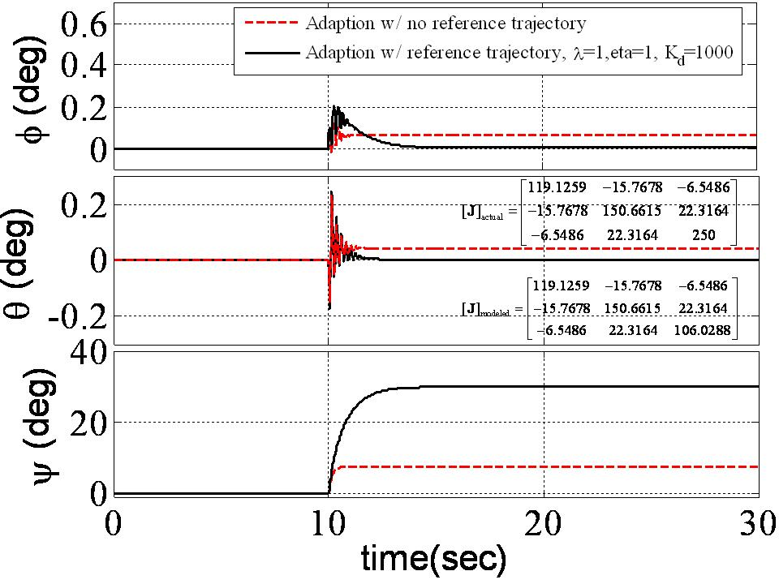
Figure 13 Indirect adaptive control with and without reference trajectory

Indirect Adaption with Reference Trajectory

Having established adaptive feedforward control is most effective with a reference trajectory, the following section iterates the design scale constant, λ. As seen in Figure 14, lower values of scale constant, λ result in slower controlled response. As λ is increased, system response is faster, but oscillations are increased. Scale constant value between one and five result in good performance preferring a value closer to one to avoid the oscillatory response. At the very least, simulations indicate the adaptive control approach seems quite successful for application on TASS2 three axis satellite simulator with recently added equipment changing system inertia.
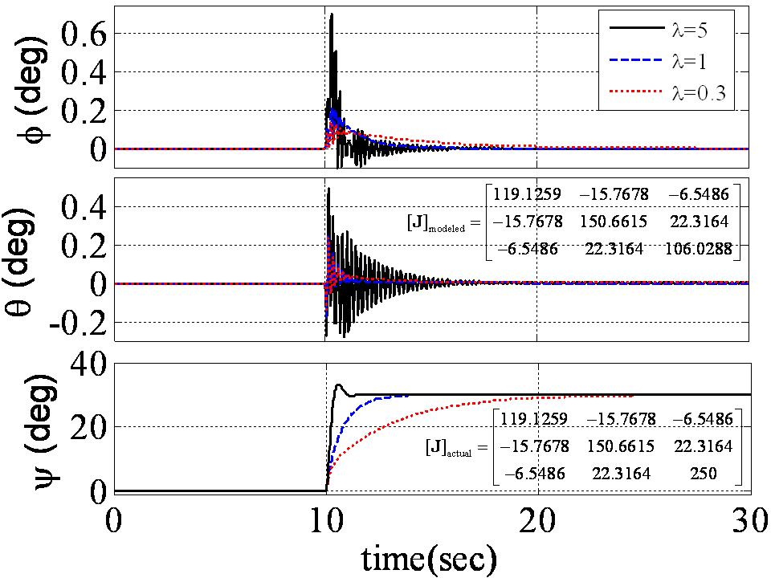
Figure 14 Effects of scale constant λ on indirect adaptive control with reference trajectory

In order to consider actual application of the adaptive control technique on the actual TASS2 hardware, we must include noisy gyro measurements like Figure 2. Noise spikes were added to the simulation to closely mimic the actual noise per Figure 15. Firstly, the noisy measurements were fed directly to the adaptive feedforward algorithm (adaptive estimation with reference trajectory). Figure 16 illustrates the impact of the noise on tracking performance. While the higher scale constant λ generally improves system response, it also exacerbates the impact of system noise. With no sensor measurement smoothing, a scale constant λ=1 seems to be a good compromise. Rather than consider a computationally demanding algorithm like a Kalman filter, first consider a simple data smoothing scheme. One simple approach is to utilize a percentage of the current measurement and past measurement using a simple unit-time delay. The fraction of the current measurement used is referred to as a smoothing ratio.
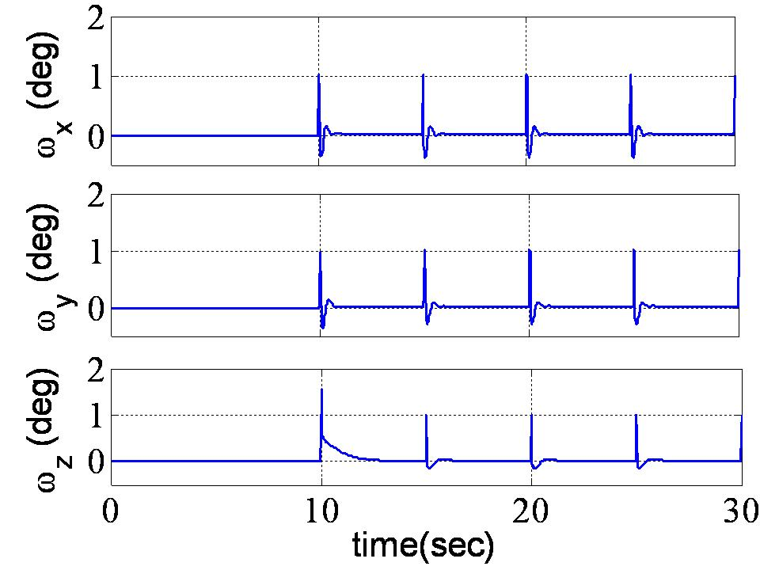
Figure 15 Simulated noisy angular rate ω measurements

Figure 17 displays the same 30º ψ yaw attitude maneuver with a angular rate smoothing ratio of 0.5. This means ½ of the current gyro measurement is added to ½ of the previous measurement. Immediately we see the exacerbation of system noise with high scale constant λ has been eliminated. Decreasing the smoothing ratio still further degrades smoothing effectiveness. Notice when the smoothing ratio in decreased to 0.3 (30% of the current measurement is added to 70% of the previous measurement) as in Figure 18, system maneuver overshoot is increased slightly. The response is still better than the no-smoothing case, so smoothing should be considered for real world application.
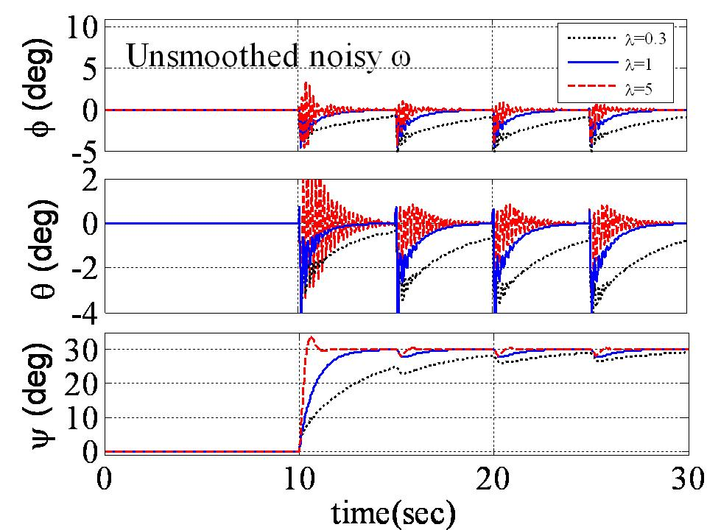
Figure 16 Euler angles with unsmoothed noisy ω measurements

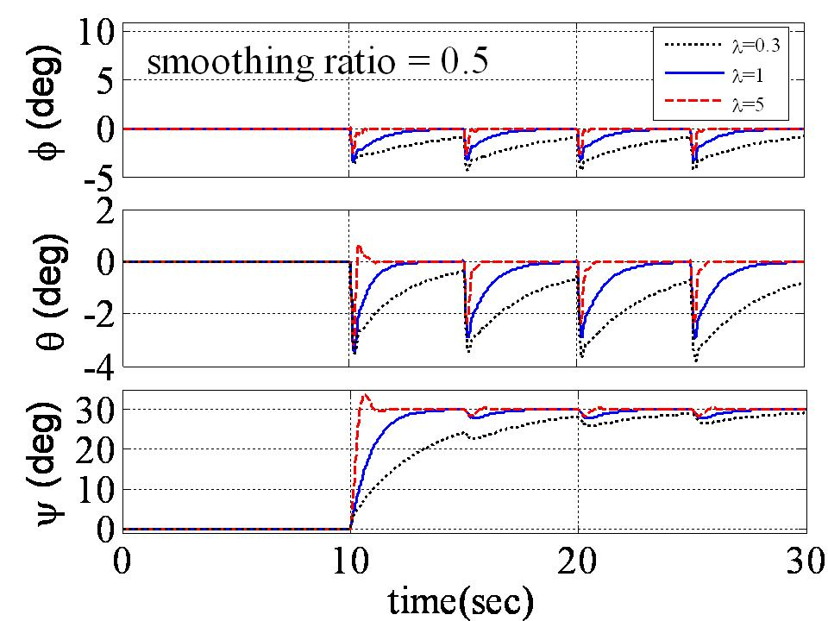
Figure 17 Euler angles with noisy ω measurements and smoothing ratio=0.5

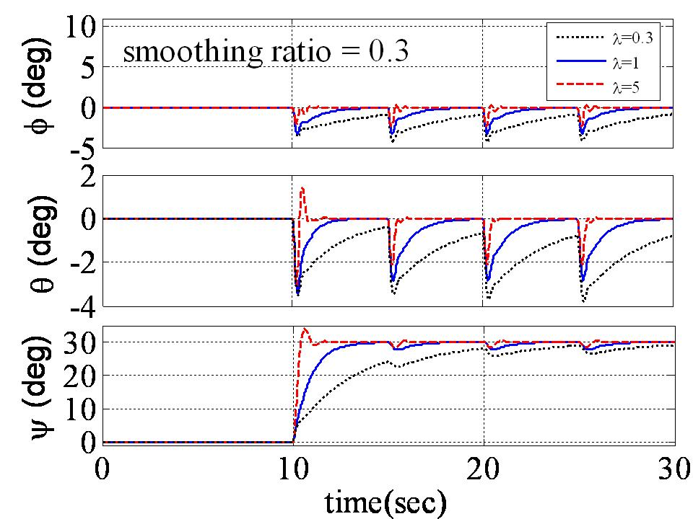
Figure 18 Euler angles with noisy w measurements and smoothing ratio=0.3

Experimental Verification
While theory contends adaptive control with both estimation and a scaled reference trajectory is stable and effective, simulations help give confidence the technique is worthy of application. Following the previous successful simulations, it is appropriate to verify the conclusions experimentally. Utilizing the free-floating three-axis spacecraft simulator (TASS2) at the Naval Postgraduate School’s Spacecraft Research and Design Center, yaw maneuver experiments provide experimental verification. An +8º yaw maneuver is immediately followed by a -8º yaw maneuver back to the initial attitude, then regulation at zero for a total experiment time of 90 seconds. The resulting 3-dimensional momentum trajectories are depicted in Figure 19 with the nominal PD controlled case on the left and the adaptive control case on the right. Feedbacks gains were matched to explore the impact of the adaptive feedforward command. The initial -8º maneuver is accomplished by the CMGs absorbing negative momentum generating a positive momentum accumulation in the spacecraft to maintain equilibrium. The positive change in spacecraft momentum generates a positive z-axis torque. The plot displays the negative momentum generation (lower path) followed by the positive momentum generation (upper path). Notice the momentum generation is dramatically higher for the adaptive control case. This is expected, as the adaptive controller adds control components to the nominal feedback control components.
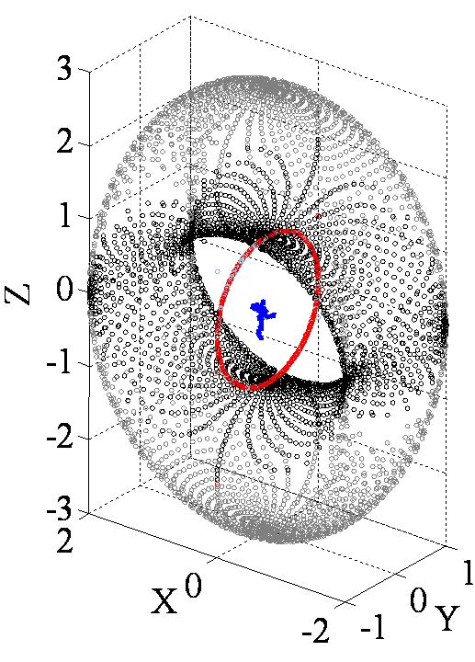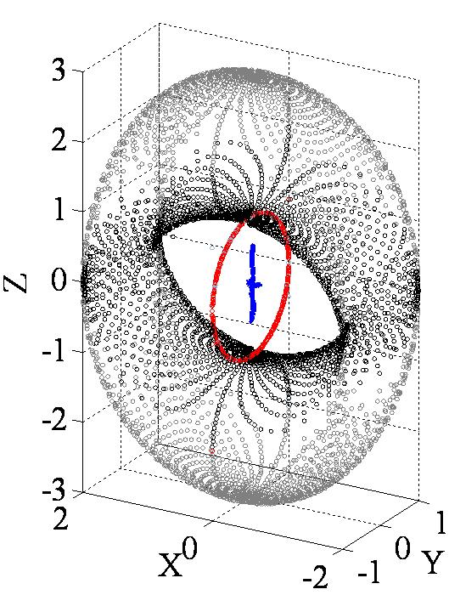
Figure 19 Maneuver 3D Momentum Trajectory (left) PD Control and (right) Adaptive Control

Next, notice in Figure 20 the angular rate measurements from the 2 experiments. Both experiments exhibit the anticipated noise spikes, thus both experiments utilized a 50% smoothing ratio on angular rate measurements. 50% of any current measurement is mixed with 50% of the previous measurement effectively smoothing the impacts of the noise spikes.
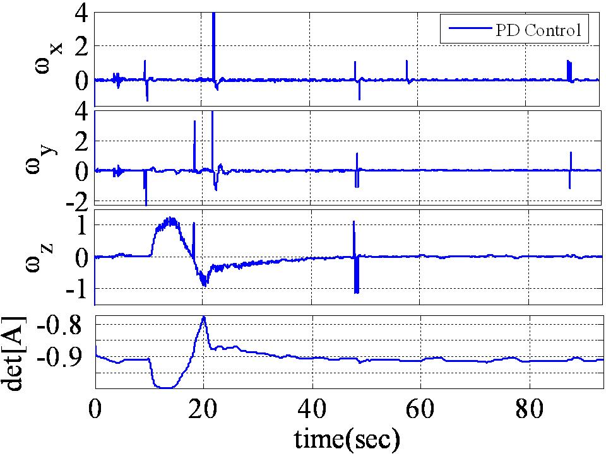

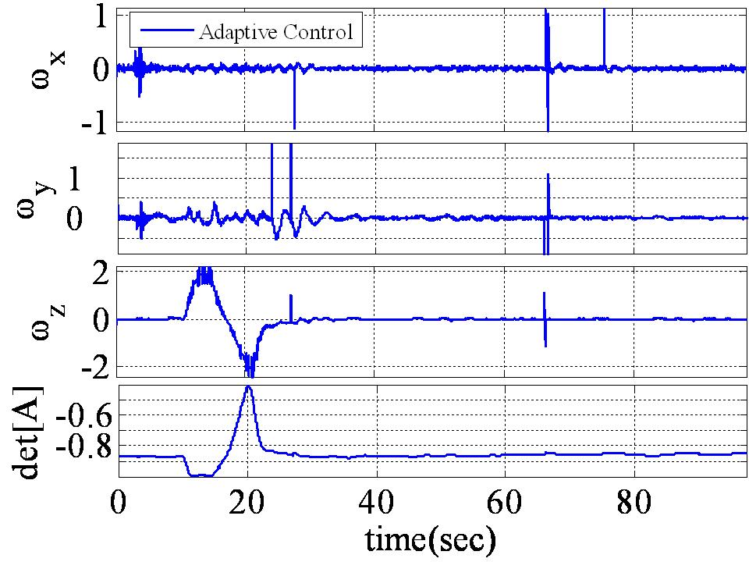
Figure 20 Angular Rate (deg/s) for (top) PD Control (bottom) Adaptive Control Experiment
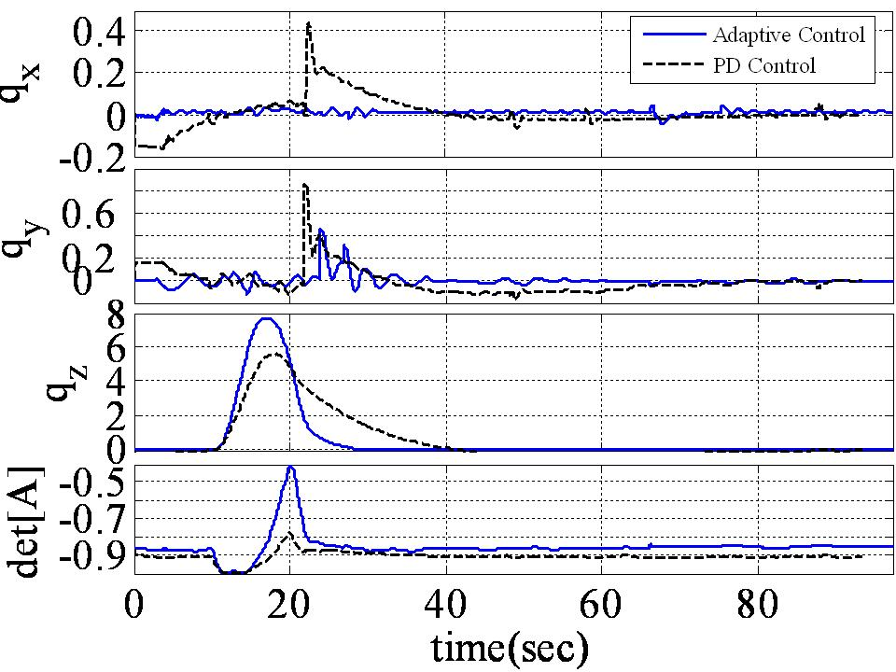
Figure 21 Experimental maneuver rotation angle with PD Control Vs. Adaptive Control

Figure 21 demonstrates the superior tracking of the adaptive control method. The PD control is still attempting to complete the initial positive rotation when the reverse rotation is commanded, while the adaptive control has nearly accomplished the entire aggressive maneuver. Additionally, the maneuver reversal is accomplished rapidly and the return to the initial attitude is rapid. In both cases of roll and pitch errors are also considerably reduced. These two maneuvers were performed in an “apples-to-apples” comparison. Every aspect of the software was identical. One signal manual switch was included in the control to switch between classical PD control and adaptive control. Gimbal angles and normalized momentum for the experiments are plotted for comparison in Figure 22 and Figure 23 with the normalized momentum magnitude and determinant of the steering [A] matrix included in Figure 24.
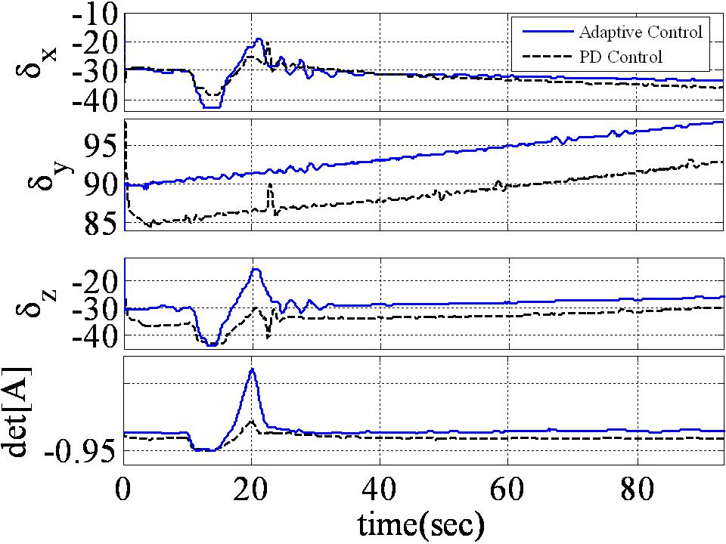
Figure 22 Experimental Gimbal Angles Comparison PD Vs. Adaptive Control

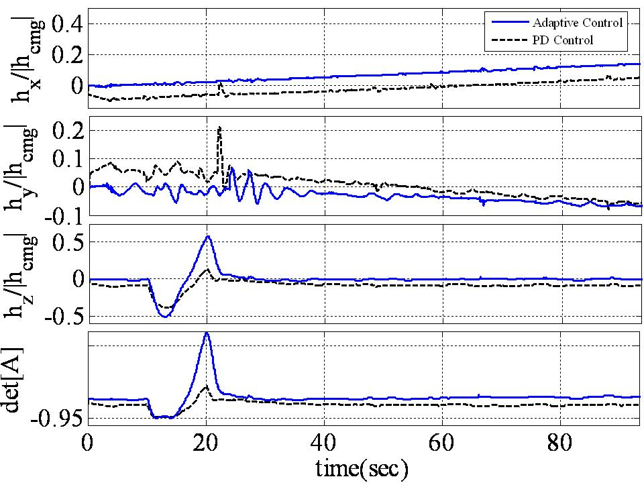
Figure 23 Experimental Normalized Momentum Comparison PD Vs. Adaptive Control
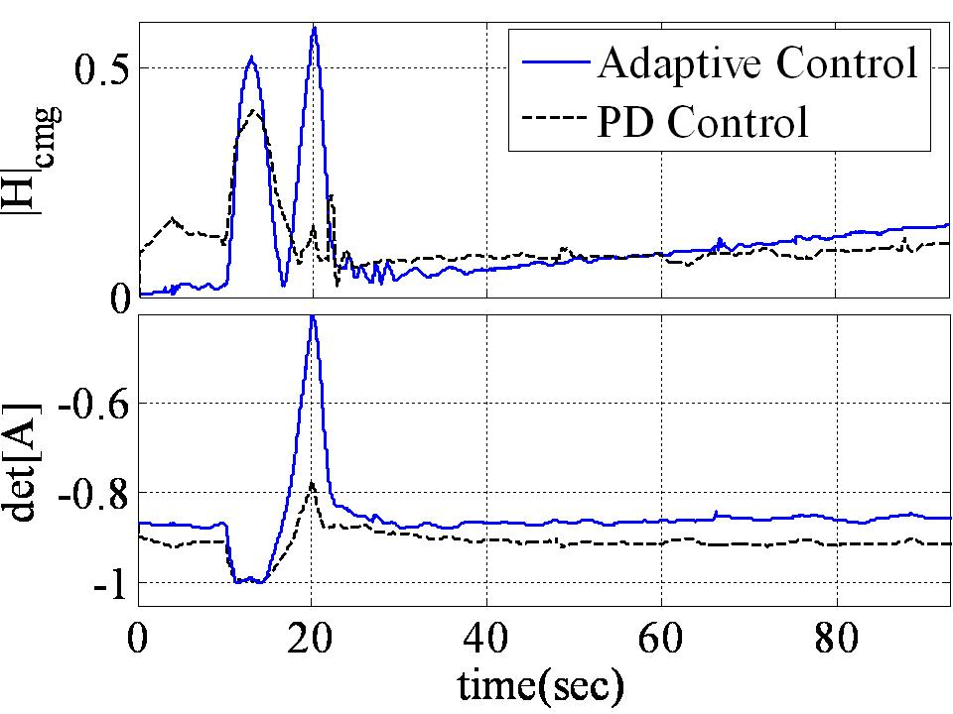
Figure 24 Experimental normalized momentum magnitude & det[A] for PD Vs. Adaptive Control

The extremely satisfying results of the previous experiment verify target tracking maneuvers can be improved with the addition of an adaptive feedforward command.

Ahmed, J. “Asymptotic Tracking of Spacecraft Attitude Motion with Inertia Identification”, AIAA Journal of Guidance, Dynamics and Control, Sep-Oct 1998.
Cristi, R., “Adaptive Quaternion Feedback Regulation for Eigenaxis Rotation”, AIAA Journal of Guidance, Dynamics and Control, Nov-Dec 1994.
Sanya, A. “Globally Convergent Adaptive Tracking of Spacecraft Angular Velocity with Inertia Identification”, Proceedings of IEEE Conference of Decision and Control, 2003.
Niemeyer, G. and Slotine, J.J.E, “Performance in adaptive manipulator control”, Proceedings of 27th IEEE Conference on Decision and Control, Decemebr, 1988.
Slotine, J.J.E. and Benedetto, M.D.Di, “Hamiltonian Adaptive Control of Spacecraft”, IEEE Transactions on Automatic Control, Vol. 35, pp. 848-852, July 1990.
Fossen, T. “Comments on ‘Hamiltonian Adaptive Control of Spacecraft’ “, IEEE Transactions on Automatic Control, Vol. 38., No. 4, April 1993.

